**Assignment 04**

***Place your code after each question***

The following list reflects common data requests from city managers. Write the SQL statements to satisfy the requests. If the query can be accomplished by using different operators, supply alternative solutions so that the performance-tuning group can test them and identify the more efficient statements. Test the statements and show execution results.

1. List all criminal aliases beginning with the letter B.

USE CityJailSummerDB

SELECT * FROM aliases

WHERE alias LIKE 'B%'

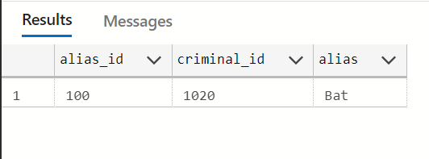

1. List all crimes that occurred (were charged) during the month October 2008. List the crime ID, criminal ID, date charged, and classification.

USE CityJailSummerDB

SELECT crime_id, criminal_id, date_charged, classification FROM crimes

WHERE MONTH(date_charged) = 10 AND YEAR(date_charged) = 2008

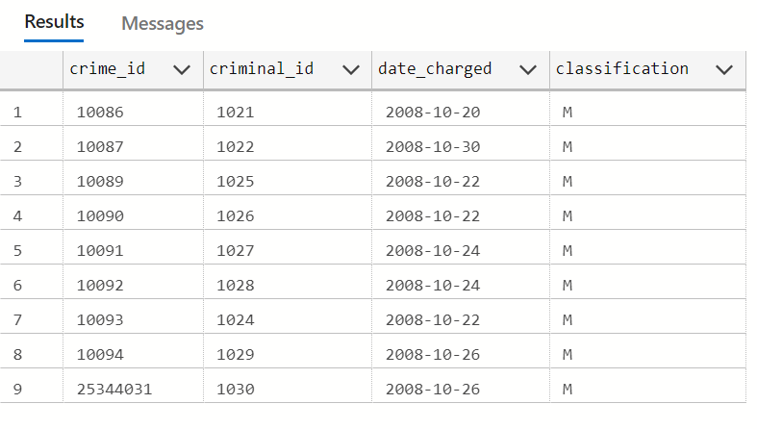

1. List all crimes with a status of CA (can appeal) or IA (in appeal). List the crime ID, criminal ID, date charged, and status.

USE CityJailSummerDB

SELECT crime_id, criminal_id, date_charged, [status] FROM crimes

WHERE [status] = 'CA' OR [status] = 'IA'

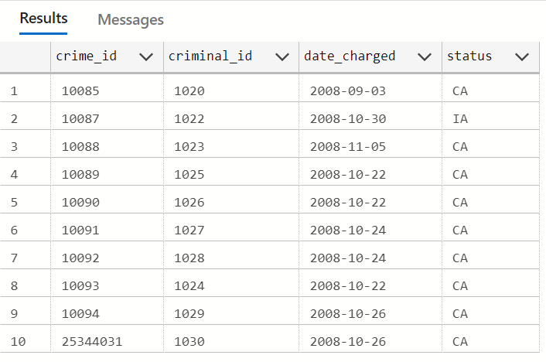

1. List all crimes classified as a felony. List the crime ID, criminal ID, date charged, and classification.

USE CityJailSummerDB

SELECT crime_id, criminal_id, date_charged, classification FROM crimes

WHERE classification = 'F'

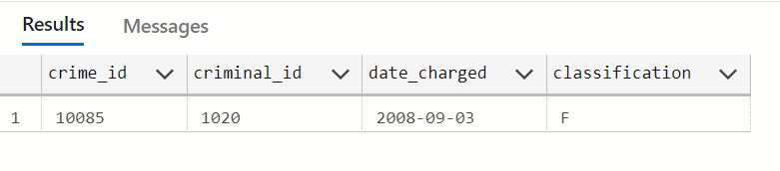

1. List all crimes with a hearing date more than 14 days after the date charged. List the crime ID, criminal ID, date charged, and hearing date.

USE CityJailSummerDB

SELECT crime_id, criminal_id, date_charged, hearing_date FROM crimes

WHERE DATEDIFF(DAY, date_charged, hearing_date) > 14

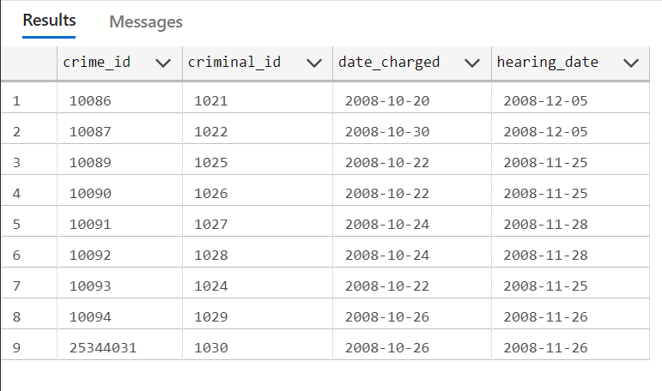

1. List all criminals with the zip code 23510. List the criminal ID, last name, and zip code. Sort the list by criminal ID.

USE CityJailSummerDB

SELECT criminal_id, [last], zip FROM criminals

WHERE zip = 23510

ORDER BY criminal_id

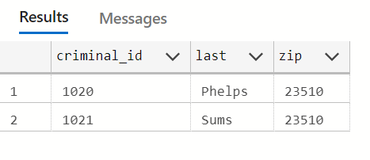

1. List all crimes that don’t have a hearing date scheduled. List the crime ID, criminal ID, date charged, and hearing date.

USE CityJailSummerDB

SELECT crime_id, criminal_id, date_charged, hearing_date FROM crimes

WHERE hearing_date IS NULL

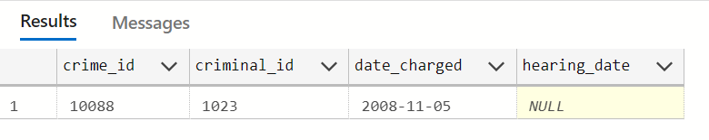

1. List all sentences with a probation officer assigned. List the sentence ID, criminal ID, and probation officer ID. Sort the list by probation officer ID and then criminal ID.

USE CityJailSummerDB

SELECT sentence_id, criminal_id, prob_id FROM sentences

WHERE [prob_id] IS NOT NULL

ORDER BY prob_id

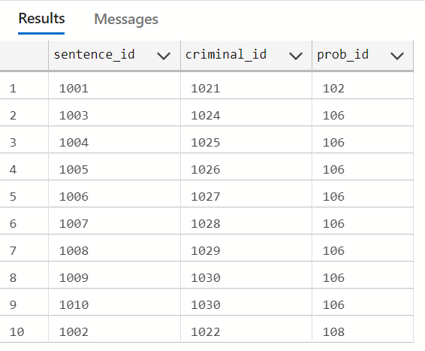

USE CityJailSummerDB

SELECT sentence_id, criminal_id, prob_id FROM sentences

WHERE [prob_id] IS NOT NULL

ORDER BY criminal_id

